DAY2

Assignment 1: Book Management System
Book.h
C++
#ifndef BOOK_H
#define BOOK_H
#include <string>
using namespace std;

class Book {
private:
int id;
string title;
string author;
float price;
int quantity;
public:
Book();
void accept();
void display();
// Getters and Setters
void setPrice(float p);
float getPrice();
float calculateTotalValue();
};
#endif
Book.cpp
C++
#include "Book.h"
#include <iostream>

Book::Book() : id(0), title("Not Available"), author("Unknown"), price(0.0f), quantity(0) {}

void Book::accept() {
cout << "Enter Book ID: "; cin >> id;
cout << "Enter Title: "; cin.ignore(); getline(cin, title);
cout << "Enter Author: "; getline(cin, author);
cout << "Enter Price: "; cin >> price;
cout << "Enter Quantity: "; cin >> quantity;
}

void Book::display() {
cout << "\nID: " << id << "\nTitle: " << title << "\nAuthor: " << author
<< "\nPrice: " << price << "\nQuantity: " << quantity << endl;
}

void Book::setPrice(float p) { price = p; }
float Book::getPrice() { return price; }
float Book::calculateTotalValue() { return price * quantity; }

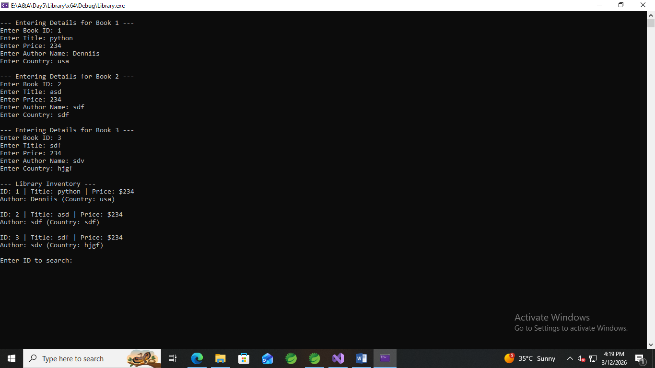

DAY 3

Day 5

1. Book and Author (Containment with Array of
Objects + Utility Class)

Author.h
#ifndef AUTHOR_H
#define AUTHOR_H
#include <iostream>
#include <string>
using namespace std;

class Author {
private:
string authorName;
string country;
public:
void acceptAuthor();
void displayAuthor();
string getAuthorName(); // Getter needed for searching
};
#endif

Author.cpp#include "Author.h"

void Author::acceptAuthor() {
cout << "Enter Author Name: ";
cin.ignore();
getline(cin, authorName);
cout << "Enter Country: ";
getline(cin, country);
}

void Author::displayAuthor() {
cout << "Author: " << authorName << " (Country: " << country << ")" << endl;
}

string Author::getAuthorName() {
return authorName;
} Book.h#ifndef BOOK_H
#define BOOK_H
#include "Author.h"

class Book {
private:
int bookId;
string bookTitle;
double price;
Author author; // Containment: Book "has-a" Author
public:
void acceptBook();
void displayBook();
int getBookId();
Author getAuthorObj();
};
#endif Book.cpp#include "Book.h"

void Book::acceptBook() {
cout << "Enter Book ID: ";
cin >> bookId;
cout << "Enter Title: ";
cin.ignore();
getline(cin, bookTitle);
cout << "Enter Price: ";
cin >> price;
author.acceptAuthor(); // Calling Author's accept
}

void Book::displayBook() {
cout << "\nID: " << bookId << " | Title: " << bookTitle << " | Price: $" << price << endl;
author.displayAuthor(); // Calling Author's display
}

int Book::getBookId() { return bookId; }
Author Book::getAuthorObj() { return author; }

PrintToScreen.h #ifndef PRINTTOSCREEN_H
#define PRINTTOSCREEN_H
#include "Book.h"

class PrintToScreen {
public:
static void acceptBooks(Book b[], int size);
static void displayBooks(Book b[], int size);
static void searchById(Book b[], int size, int id);
static void searchByAuthor(Book b[], int size, string authorName);
};
#endif
├── PrintToScreen.cpp #include "PrintToScreen.h"

void PrintToScreen::acceptBooks(Book b[], int size) {
for(int i = 0; i < size; i++) {
cout << "\n--- Entering Details for Book " << (i+1) << " ---" << endl;
b[i].acceptBook();
}
}

void PrintToScreen::displayBooks(Book b[], int size) {
for(int i = 0; i < size; i++) {
b[i].displayBook();
}
}

void PrintToScreen::searchById(Book b[], int size, int id) {
bool found = false;
for(int i = 0; i < size; i++) {
if(b[i].getBookId() == id) {
b[i].displayBook();
found = true;
break;
}
}
if(!found) cout << "Book with ID " << id << " not found." << endl;
}

void PrintToScreen::searchByAuthor(Book b[], int size, string name) {
bool found = false;
for(int i = 0; i < size; i++) {
if(b[i].getAuthorObj().getAuthorName() == name) {
b[i].displayBook();
found = true;
}
}
if(!found) cout << "No books found for author: " << name << endl;
}
└── main.cpp
#include "PrintToScreen.h"

int main() {
const int SIZE = 3;
Book library[SIZE];

// Using Static Utility Methods
PrintToScreen::acceptBooks(library, SIZE);

cout << "\n--- Library Inventory ---";
PrintToScreen::displayBooks(library, SIZE);

int sId;
cout << "\nEnter ID to search: ";
cin >> sId;
PrintToScreen::searchById(library, SIZE, sId);

string sAuthor;
cout << "\nEnter Author Name to search: ";
cin.ignore();
getline(cin, sAuthor);
PrintToScreen::searchByAuthor(library, SIZE, sAuthor);

return 0;
}
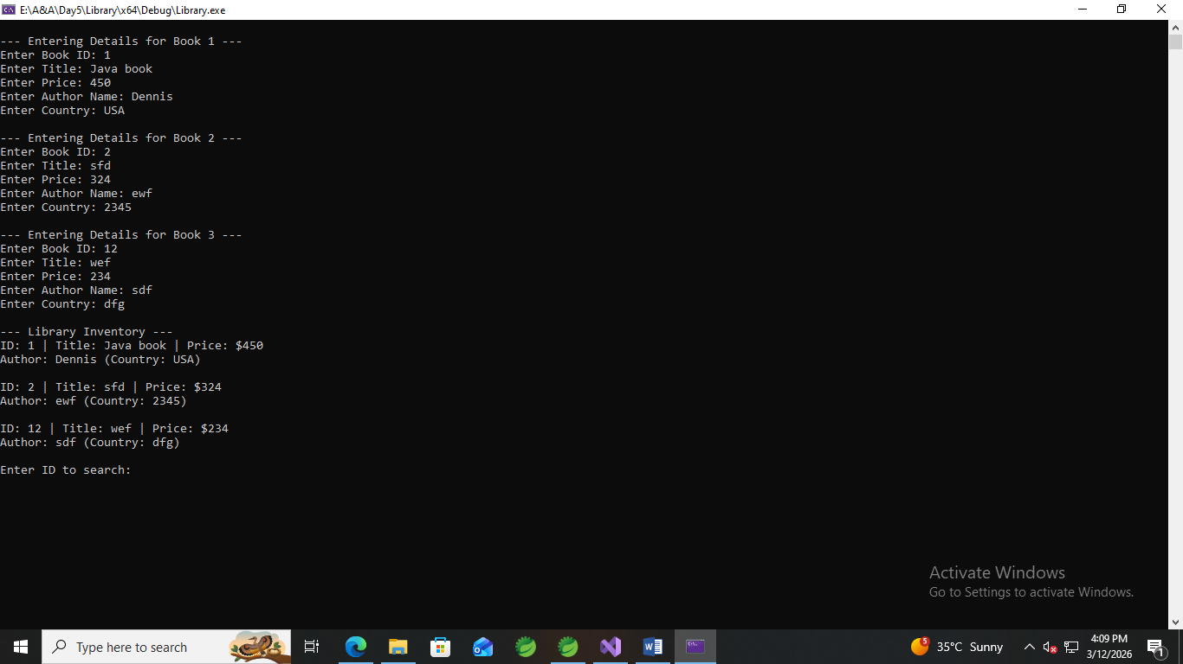

2. Problem Statement: Healthcare Management System
Client_main.cpp
#include "Doctor.h"
#include "Nurse.h"
#include "LabTechnician.h"

int main() {
Doctor d;
Nurse n;
LabTechnician l;

cout << "--- INPUT SECTION ---" << endl;
d.acceptDoctorDetails();
n.acceptNurseDetails();
l.acceptLabTechnicianDetails();

cout << "\n--- OUTPUT SECTION ---" << endl;
d.displayDoctorDetails();
n.displayNurseDetails();
l.displayLabTechnicianDetails();

return 0;
}
Doctor.h
#include "Doctor.h"
#include "Nurse.h"
#include "LabTechnician.h"

int main() {
Doctor d;
Nurse n;
LabTechnician l;

cout << "--- INPUT SECTION ---" << endl;
d.acceptDoctorDetails();
n.acceptNurseDetails();
l.acceptLabTechnicianDetails();

cout << "\n--- OUTPUT SECTION ---" << endl;
d.displayDoctorDetails();
n.displayNurseDetails();
l.displayLabTechnicianDetails();

return 0;
}

Doctor_src.cpp
#include"Doctor.h"

Doctor::Doctor()
{
specialization = "";
consultationFee = 0.0;
exp = 0;
yi = 0.0;
}

void Doctor::acceptDoctorDetails()
{
cout << "\nDOCTOR DETAILS : ";
MedicalStaff::acceptStaffDetails();
cout << "\nSpecialization : ";
cin >> specialization;
cout << "\nConsultation Fee : ";
cin >> consultationFee;
cout << "\nExp : ";
cin >> exp;

int patients;
cout << "Estimated Patients Per Month: ";
cin >> patients;

yi = consultationFee * patients * 12;
}

void Doctor::displayDoctorDetails()
{
MedicalStaff::displayStaffDetails();
cout << "\nDoctor Details : \nSpecialization : " << specialization << "\nConsultation Fee : " << consultationFee << "\nExperience : " << exp<<"\nYearly Income : "<<yi<<endl;
}

double Doctor::yearlyIncome()
{
return yi;
}

Lab_technician.h
#pragma once
#include"MedicalStaff.h"

class LabTechnician :public MedicalStaff
{
private:
string labType;
int numberOfTestsHandledPerDay;
double salary;
public:
LabTechnician();
void acceptLabTechnicianDetails();
void displayLabTechnicianDetails();
};

Lab_technician_src.cpp
#include"LabTechnician.h"
void LabTechnician ::acceptLabTechnicianDetails()
{
cout << "\nLAB TECHNICIAN DETAILS : ";
MedicalStaff::acceptStaffDetails();
cout << "Enter Lab Technician Details : ";
cout << "\nLab Type : ";
cin >> labType;
cout << "\nNumber of tests Handled Per Day : ";
cin >> numberOfTestsHandledPerDay;
cout << "\nSalary : ";
cin >> salary;
}

LabTechnician::LabTechnician()
{
labType="";
numberOfTestsHandledPerDay=0;
salary=0.0;
}

void LabTechnician::displayLabTechnicianDetails()
{
MedicalStaff::displayStaffDetails();
cout << "\nLab Technician Details : \nLab Type : " << labType << "\nNumber of Tests Handled Per Day : " << numberOfTestsHandledPerDay << "\nSalary : " << salary<<endl;
}

MedicalStaff.h
#pragma once
#include<iostream>
using namespace std;

class MedicalStaff
{
protected:
int age, staffId;
string name;
string contactNumber;
public:
MedicalStaff();
void acceptStaffDetails();
void displayStaffDetails();
};

MedicalStaff_src.cpp
#include"MedicalStaff.h"

MedicalStaff::MedicalStaff()
{
age = 0;
staffId=0;
name="";
contactNumber = "";
}

void MedicalStaff::acceptStaffDetails()
{
cout << "\nEnter Medical Staff Details : ";
cout << "\nName : ";
cin >> name;
cout << "\nAge : ";
cin >> age;
cout << "\nStaff Id : ";
cin >> staffId;
cout << "\nEnter Contact Number : ";
cin >> contactNumber;
}
void MedicalStaff::displayStaffDetails()
{
cout << "\nMedical Staff Details : \nName : "<<name<<"\nAge : "<<age<<"\nStaff ID : "<<staffId<<"\ncontact Number : "<<contactNumber;
}

Nurse.h
#pragma once
#include"MedicalStaff.h"

class Nurse :public MedicalStaff
{
private:
string shift, wardAssigned;
double salary;
public:
Nurse();
void acceptNurseDetails();
void displayNurseDetails();
};

Nurse_src.cpp
#include"Nurse.h"

Nurse::Nurse()
{
shift = "";
wardAssigned = "";
salary = 0.0;
}

void Nurse:: acceptNurseDetails()
{
cout << "\nNURSE DETAILS : ";
MedicalStaff::acceptStaffDetails();
cout << "\nShift (Day/Night): ";
cin >> shift;
cout << "\nWard Assigned : ";
cin >> wardAssigned;
cout << "\nSalary : ";
cin >> salary;
}

void Nurse::displayNurseDetails()
{
MedicalStaff::displayStaffDetails();
cout << "\nNurse Details : \nShift : " << shift << "\nWard Assigned : " << wardAssigned << "\nSalary : " << salary<<endl;
}

